1. Declare a single-dimensional array of 5 integers inside the main method. Traverse the array to print the default values. Then accept records from the user and print the updated values of the array.

Solution:

package assignment6.in;

import java.util.Scanner;

public class Program1 {

public static void main(String[] args) {

int[] numbers = new int[5];

System.*out*.println("Default values of the array:");

for (int i = 0; i < numbers.length; i++) {

System.*out*.println("Element at index " + i + ": " + numbers[i]);

}

Scanner scanner = new Scanner(System.*in*);

System.*out*.println("\nEnter 5 integers to update the array:");

for (int i = 0; i < numbers.length; i++) {

System.*out*.print("Enter value for index " + i + ": ");

numbers[i] = scanner.nextInt();

}

System.*out*.println("\nUpdated values of the array:");

for (int i = 0; i < numbers.length; i++) {

System.*out*.println("Element at index " + i + ": " + numbers[i]);

}

scanner.close();

}

}

Output:

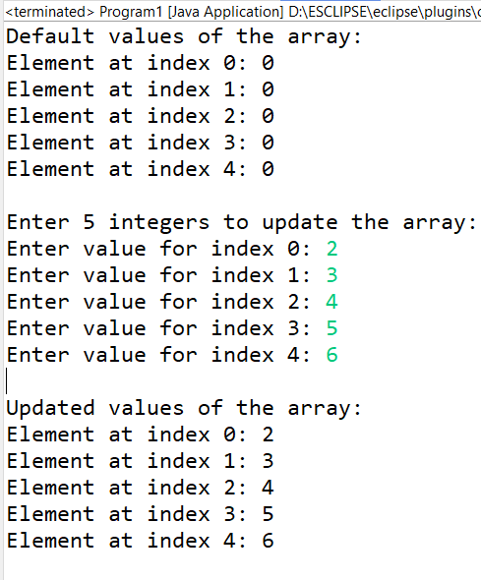

1. Declare a single-dimensional array of 5 integers inside the main method. Define a method named acceptRecord to get input from the terminal into the array and another method named printRecord to print the state of the array to the terminal.

Solution:

package assignment2.in;

import java.util.Scanner;

public class Program2 {

public static void acceptRecord(int[] arr) {

Scanner scanner = new Scanner(System.*in*);

System.*out*.println("Enter 5 integers:");

for (int i = 0; i < arr.length; i++) {

arr[i] = scanner.nextInt();

}

scanner.close();

}

public static void printRecord(int[] arr) {

System.*out*.println("The array elements are:");

for (int i = 0; i < arr.length; i++) {

System.*out*.print(arr[i] + " ");

}

System.*out*.println();

}

public static void main(String[] args) {

int[] arr = new int[5];

*acceptRecord*(arr);

*printRecord*(arr);

}

}

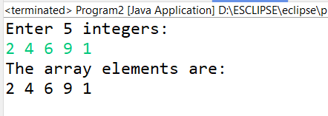

1. Write a program to find the maximum and minimum values in a single-dimensional array of integers.

Solution:

package assignment2.in;

import java.util.Scanner;

public class Program3 {

public static int findMax(int[] arr) {

int max = arr[0];

for (int i = 1; i < arr.length; i++) {

if (arr[i] > max) {

max = arr[i];

}

}

return max;

}

public static int findMin(int[] arr) {

int min = arr[0];

for (int i = 1; i < arr.length; i++) {

if (arr[i] < min) {

min = arr[i];

}

}

return min;

}

public static void main(String[] args) {

Scanner scanner = new Scanner(System.*in*);

System.*out*.print("Enter the number of elements in the array: ");

int n = scanner.nextInt();

int[] arr = new int[n];

System.*out*.println("Enter " + n + " integers:");

for (int i = 0; i < arr.length; i++) {

arr[i] = scanner.nextInt();

}

int max = *findMax*(arr);

int min = *findMin*(arr);

System.*out*.println("Maximum value in the array: " + max);

System.*out*.println("Minimum value in the array: " + min);

scanner.close();

}

}

Output:

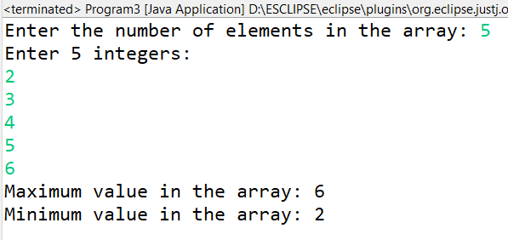

1. Write a program to remove duplicate elements from a single-dimensional array of integers.

Solution:

package assignment4.in;

import java.util.*;

public class Program4 {

public static int[] removeDuplicates(int[] arr) {

Arrays.*sort*(arr);

int[] temp = new int[arr.length];

int j = 0; // Index for the temp array

for (int i = 0; i < arr.length - 1; i++) {

if (arr[i] != arr[i + 1]) {

temp[j++] = arr[i];

}

}

temp[j++] = arr[arr.length - 1];

int[] uniqueArray = new int[j];

for (int i = 0; i < j; i++) {

uniqueArray[i] = temp[i];

}

return uniqueArray;

}

public static void main(String[] args) {

Scanner scanner = new Scanner(System.*in*);

System.*out*.print("Enter the number of elements in the array: ");

int n = scanner.nextInt();

int[] arr = new int[n];

// Accept the elements from the user

System.*out*.println("Enter " + n + " integers:");

for (int i = 0; i < arr.length; i++) {

arr[i] = scanner.nextInt();

}

// Remove duplicates and get the new array

int[] uniqueArray = *removeDuplicates*(arr);

// Display the array without duplicates

System.*out*.println("Array after removing duplicates:");

for (int i = 0; i < uniqueArray.length; i++) {

System.*out*.print(uniqueArray[i] + " ");

}

System.*out*.println();

scanner.close();

}

}

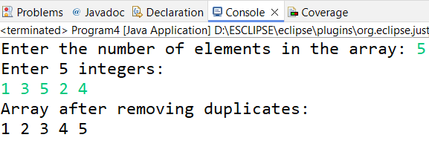

1. Write a program to find the intersection of two single-dimensional arrays.

Solution:

package assignment5.i

import java.util.*;

public class Program

// Method to find the intersection of two arrays

public static int[] findIntersection(int[] arr1, int[] arr2) {

List<Integer> intersection = new ArrayList<>();

for (int i = 0; i < arr1.length; i++) {

for (int j = 0; j < arr2.length; j++) {

if (arr1[i] == arr2[j] && !intersection.contains(arr1[i])) {

intersection.add(arr1[i]);

}

}

}

int[] result = new int[intersection.size()];

for (int i = 0; i < intersection.size(); i++) {

result[i] = intersection.get(i);

}

return result;

}

public static void main(String[] args) {

Scanner scanner = new Scanner(System.*in*)

System.*out*.print("Enter the number of elements in the first array: ");

int n1 = scanner.nextInt();

int[] arr1 = new int[n1];

System.*out*.println("Enter " + n1 + " integers for the first array:");

for (int i = 0; i < n1; i++) {

arr1[i] = scanner.nextInt();

}

System.*out*.print("Enter the number of elements in the second array: ");

int n2 = scanner.nextInt();

int[] arr2 = new int[n2];

System.*out*.println("Enter " + n2 + " integers for the second array:");

for (int i = 0; i < n2; i++) {

arr2[i] = scanner.nextInt();

}

int[] intersection = *findIntersection*(arr1, arr2);

System.*out*.println("Intersection of the two arrays: " + Arrays.*toString*(intersection));

scanner.close();

}

}

Output:

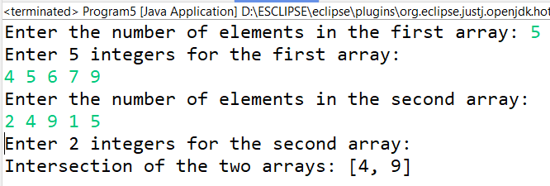

1. Write a program to find the missing number in an array of integers ranging from 1 to N.

Solution:

package assignment6.in;

import java.util.*;

public class Program6 {

// Method

public static int findMissingNumber(int[] arr, int N) {

int expectedSum = N * (N + 1) / 2; // Sum of numbers from 1 to N

int Sum = 0;

for (int num : arr) {

Sum += num;

}

return expectedSum - Sum;

}

public static void main(String[] args) {

Scanner scanner = new Scanner(System.*in*);

System.*out*.print("Enter the value of N (the range): ");

int N = scanner.nextInt();

int[] arr = new int[N - 1]; // Array size is N-1 as one number is missing

System.*out*.println("Enter " + (N - 1) + " integers:");

for (int i = 0; i < arr.length; i++) {

arr[i] = scanner.nextInt();

}

int missingNumber = *findMissingNumber*(arr, N);

System.*out*.println("The missing number is: " + missingNumber);

scanner.close();

}

}

Output:

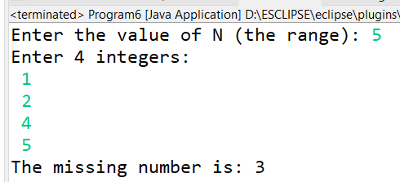

1. Declare a single-dimensional array as a field inside a class and instantiate it inside the class constructor. Define methods named acceptRecord and printRecord within the class and test their functionality.

Solution:

package assignment.in;

import java.util.Scanner;

class Array {

private int[] arr; // Single-dimensional array as a field

// Constructor to instantiate the array

public Array(int size) {

arr = new int[size]; // Instantiate the array

}

public void acceptRecord() {

Scanner scanner = new Scanner(System.*in*);

System.*out*.println("Enter " + arr.length + " integers:");

for (int i = 0; i < arr.length; i++) {

arr[i] = scanner.nextInt()

}

scanner.close();

}

public void printRecord() {

System.*out*.println("Array elements are:");

for (int num : arr) {

System.*out*.print(num + " ");

}

System.*out*.println();

}

}

public class Arrray {

public static void main(String[] args) {

Scanner scanner = new Scanner(System.*in*);

System.*out*.print("Enter the size of the array: ");

int size = scanner.nextInt();

Array Rahul= new Array(size);

Rahul.acceptRecord();

Rahul.printRecord();

scanner.close();

}

}

Output:

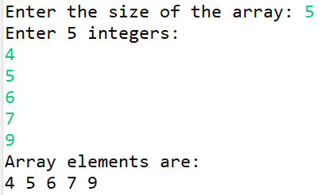

1. Modify the previous assignment to use getter and setter methods instead of acceptRecord and printRecord.

Solution:

**package** assignment.in;

**import** java.util.Scanner;

**class** FieldArray{

**private** **int**[] arr;

**public** FieldArray(**int** size) {

arr = **new** **int**[size];

}

**public** **int**[] getArr() {

**return** arr;

}

**public** **void** setArr(**int**[] arr) {

**this**.arr = arr;

}

}

**public** **class** Array {

**public** **static** **void** main(String[] args) {

FieldArray a = **new** FieldArray(5);

Scanner sc = **new** Scanner(System.***in***);

System.***out***.println("Enter 5 integers:");

**int**[] tempArr = **new** **int**[5];

**for** (**int** i = 0; i < tempArr.length; i++) {

tempArr[i] = sc.nextInt();

}

a.setArr(tempArr);

**int**[] arr = a.getArr();

System.***out***.println("Array values:");

**for** (**int** value : arr) {

System.***out***.println(value);

}

sc.close();

}

}

Output:

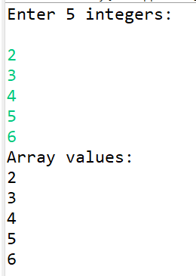

1. You need to implement a system to manage airplane seat assignments. The airplane has seats arranged in rows and columns. Implement functionalities to:

* Initialize the seating arrangement with a given number of rows and columns.
* Book a seat to mark it as occupied.
* Cancel a booking to mark a seat as available.
* Check seat availability to determine if a specific seat is available.
* Display the current seating chart.

Solution:

1. Airplane Seat:

**package** assignment.in;

**public** **class** AirplaneSeat {

**private** SeatStatus[][] seats;

**private** **int** rows;

**private** **int** columns;

// Constructor to initialize the seating arrangement

**public** AirplaneSeat(**int** rows, **int** columns) {

**this**.rows = rows;

**this**.columns = columns;

seats = **new** SeatStatus[rows][columns];

initializeSeats();

}

// Initialize all seats as available

**private** **void** initializeSeats() {

**for** (**int** i = 0; i < rows; i++) {

**for** (**int** j = 0; j < columns; j++) {

seats[i][j] = SeatStatus.***AVAILABLE***;

}

}

}

// Book a seat (mark it as BOOKED)

**public** **boolean** bookSeat(**int** row, **int** column) {

**if** (isValidSeat(row, column) && seats[row][column] == SeatStatus.***AVAILABLE***) {

seats[row][column] = SeatStatus.***BOOKED***;

**return** **true**;

}

**return** **false**;

}

// Cancel a seat booking (mark it as AVAILABLE)

**public** **boolean** cancelSeat(**int** row, **int** column) {

**if** (isValidSeat(row, column) && seats[row][column] == SeatStatus.***BOOKED***) {

seats[row][column] = SeatStatus.***AVAILABLE***;

**return** **true**;

}

**return** **false**;

}

// Check if a specific seat is available

**public** **boolean** isSeatAvailable(**int** row, **int** column) {

**if** (isValidSeat(row, column)) {

**return** seats[row][column] == SeatStatus.***AVAILABLE***;

}

**return** **false**;

}

// Display the current seating chart

**public** **void** displaySeats() {

System.***out***.println("\nCurrent Seating Chart:");

**for** (**int** i = 0; i < rows; i++) {

**for** (**int** j = 0; j < columns; j++) {

System.***out***.print(seats[i][j].getSymbol() + " ");

}

System.***out***.println();

}

}

// Helper method to check if the seat is within valid range

**private** **boolean** isValidSeat(**int** row, **int** column) {

**return** row >= 0 && row < rows && column >= 0 && column < columns;

}

}

1. AirplaneSeatUtil:

package assignment.in;

import java.util.Scanner;

public class AirplaneSeatUtil {

private static Scanner *scanner* = new Scanner(System.*in*);

// Method to take input from user

public static int getInput(String prompt) {

System.*out*.print(prompt);

return *scanner*.nextInt();

}

// Display menu options

public static void displayMenu() {

System.*out*.println("\nMenu:");

System.*out*.println("1. Book a seat");

System.*out*.println("2. Cancel a booking");

System.*out*.println("3. Check seat availability");

System.*out*.println("4. Display seating chart");

System.*out*.println("5. Exit");

System.*out*.print("Choose an option: ");

}

}

1. Seat Status

package assignment.in;

public enum SeatStatus {

*AVAILABLE*('A'),

*BOOKED*('B');

private final char symbol;

SeatStatus(char symbol) {

this.symbol = symbol;

}

public char getSymbol() {

return symbol;

}

}

1. Program:

package assignment.in;

public class Program {

public static void main(String[] args) {

System.*out*.println("Welcome to the Airplane Seat Management System!");

int rows = AirplaneSeatUtil.*getInput*("Enter number of rows: ");

int columns = AirplaneSeatUtil.*getInput*("Enter number of columns: ");

AirplaneSeat manager = new AirplaneSeat(rows, columns);

boolean exit = false;

while (!exit) {

AirplaneSeatUtil.*displayMenu*();

int choice = AirplaneSeatUtil.*getInput*("");

switch (choice) {

case 1: // Book a seat

int bookRow = AirplaneSeatUtil.*getInput*("Enter row to book: ");

int bookCol = AirplaneSeatUtil.*getInput*("Enter column to book: ");

if (manager.bookSeat(bookRow, bookCol)) {

System.*out*.println("Seat booked successfully.");

} else {

System.*out*.println("Seat already booked or invalid seat.");

}

break;

case 2: // Cancel a booking

int cancelRow = AirplaneSeatUtil.*getInput*("Enter row to cancel: ");

int cancelCol = AirplaneSeatUtil.*getInput*("Enter column to cancel: ");

if (manager.cancelSeat(cancelRow, cancelCol)) {

System.*out*.println("Booking canceled successfully.");

} else {

System.*out*.println("No booking found or invalid seat.");

}

break;

case 3: // Check seat availability

int checkRow = AirplaneSeatUtil.*getInput*("Enter row to check: ");

int checkCol = AirplaneSeatUtil.*getInput*("Enter column to check: ");

if (manager.isSeatAvailable(checkRow, checkCol)) {

System.*out*.println("Seat is available.");

} else {

System.*out*.println("Seat is not available.");

}

break;

case 4: // Display seating chart

manager.displaySeats();

break;

case 5: // Exit

exit = true;

System.*out*.println("Exiting system.");

break;

default:

System.*out*.println("Invalid option! Please try again.");

}

}

}

}

Output:

